Surface

Definition
# Source: AI Source: Provided by: [Data Path: Persons Table -> ID Column: 1, Name_En Column: Motasem Essam] -> From: [ChatGPT] on [7/20/2026]
A surface is a two-dimensional geometric object or set of points that represents the boundary, outer layer, or continuous extent of an object in space.
A surface has length and width, but in ideal Euclidean geometry it has no thickness.
Examples include:
- A flat tabletop modeled as a plane surface
- The surface of a sphere
- The curved surface of a cylinder
- The surface of a cone
- The faces of a polyhedron
In geometry, a surface can be flat or curved.

Purpose
# Source: AI Source: Provided by: [Data Path: Persons Table -> ID Column: 1, Name_En Column: Motasem Essam] -> From: [ChatGPT] on [7/20/2026]
The concept of a surface is used to:
- Describe the outer boundary of three-dimensional objects.
- Represent two-dimensional regions in three-dimensional space.
- Define faces of solid geometric figures.
- Study area and surface area.
- Distinguish between flat and curved geometric objects.
- Provide a foundation for studying three-dimensional geometry.

Fundamental Characteristics
# Source: AI Source: Provided by: [Data Path: Persons Table -> ID Column: 1, Name_En Column: Motasem Essam] -> From: [ChatGPT] on [7/20/2026]
A surface is characterized by:

1. Two Dimensions
# Source: AI Source: Provided by: [Data Path: Persons Table -> ID Column: 1, Name_En Column: Motasem Essam] -> From: [ChatGPT] on [7/20/2026]
A surface extends in two independent directions.
For example:
$$\text{Length}×\text{Width}$$
Unlike a solid, it does not have volume.

2. No Thickness
# Source: AI Source: Provided by: [Data Path: Persons Table -> ID Column: 1, Name_En Column: Motasem Essam] -> From: [ChatGPT] on [7/20/2026]
In ideal geometry, a surface has no thickness:
$$\text{Thickness}=0$$
Physical surfaces have thickness, but their ideal geometric models do not.

3. Position in Space
# Source: AI Source: Provided by: [Data Path: Persons Table -> ID Column: 1, Name_En Column: Motasem Essam] -> From: [ChatGPT] on [7/20/2026]
A surface can exist in three-dimensional space.
For example, a plane can be described by:
$$ax+by+cz=d$$
where $a$, $b$, $c$, and $d$are constants.

4. Flat or Curved
# Source: AI Source: Provided by: [Data Path: Persons Table -> ID Column: 1, Name_En Column: Motasem Essam] -> From: [ChatGPT] on [7/20/2026]
Surfaces may be:
- Flat
- Curved
- Piecewise flat
- Piecewise curved
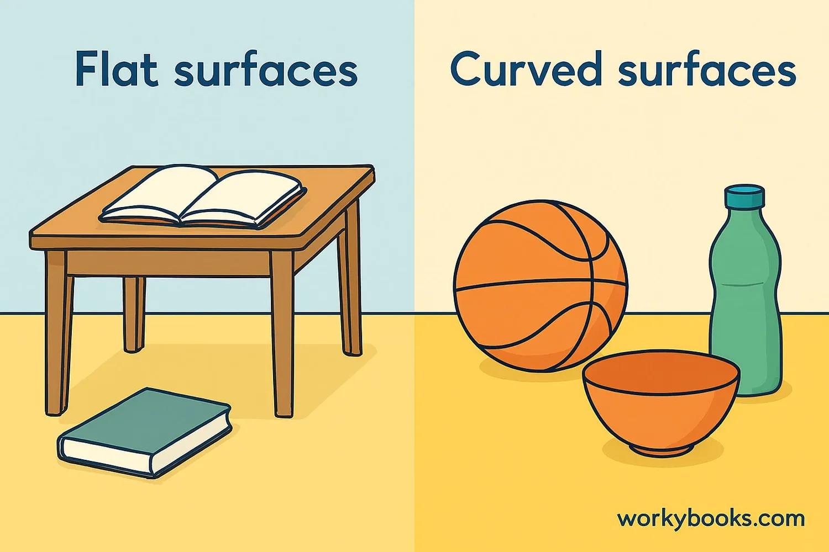
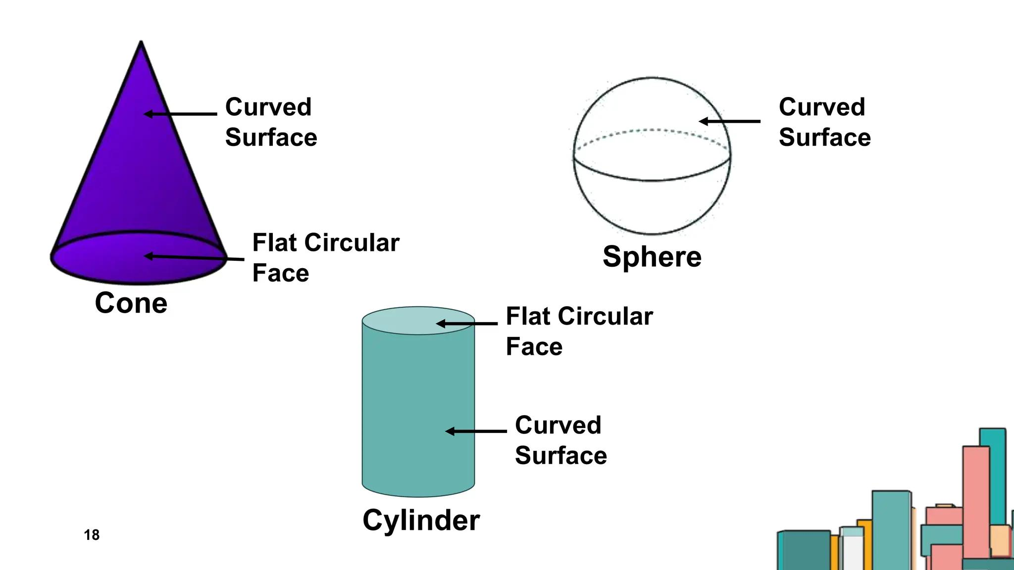
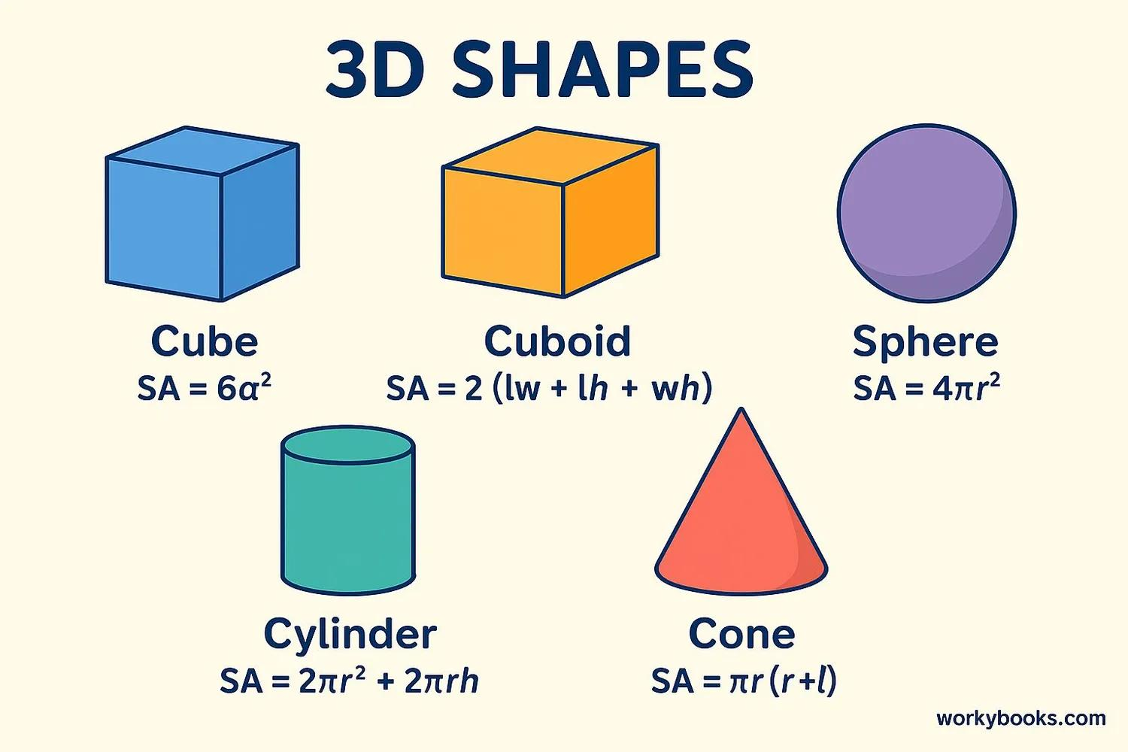

Types of Surfaces

1. Plane Surface
# Source: AI Source: Provided by: [Data Path: Persons Table -> ID Column: 1, Name_En Column: Motasem Essam] -> From: [ChatGPT] on [7/20/2026]
A plane surface is perfectly flat and extends infinitely in two dimensions.
It is modeled by the geometric concept of a plane.
Example:
$$ax+by+cz=d$$
A plane has zero curvature.

2. Curved Surface
# Source: AI Source: Provided by: [Data Path: Persons Table -> ID Column: 1, Name_En Column: Motasem Essam] -> From: [ChatGPT] on [7/20/2026]
A curved surface is a surface that is not flat over its entire extent.
Examples include:
- Sphere
- Cylinder
- Cone
- Torus
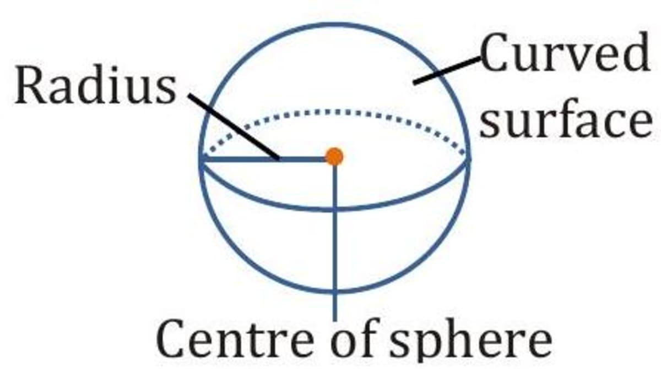
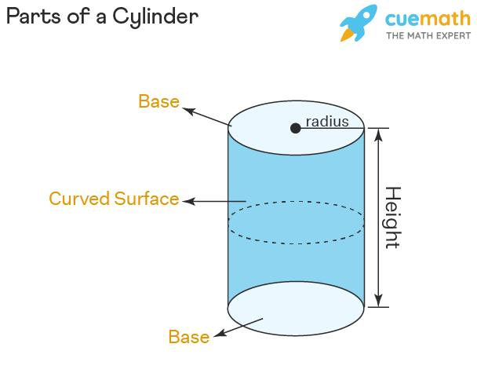
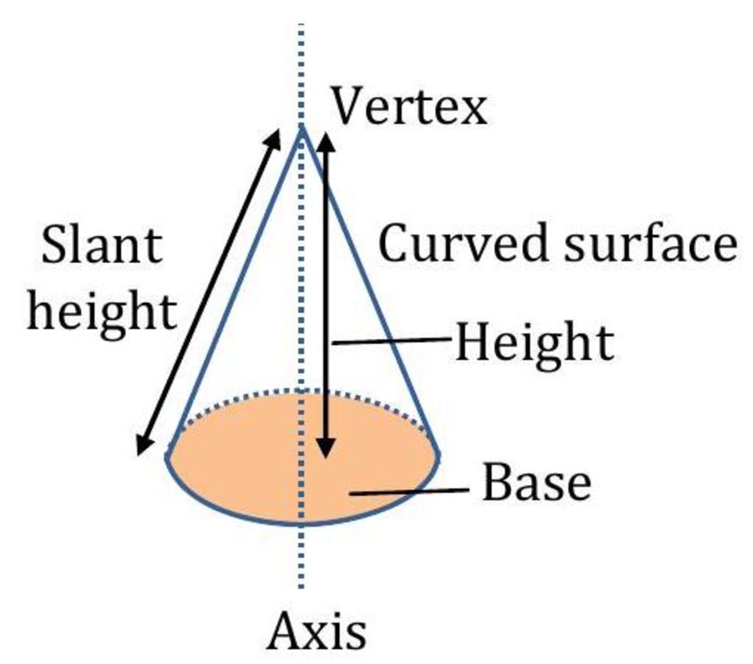
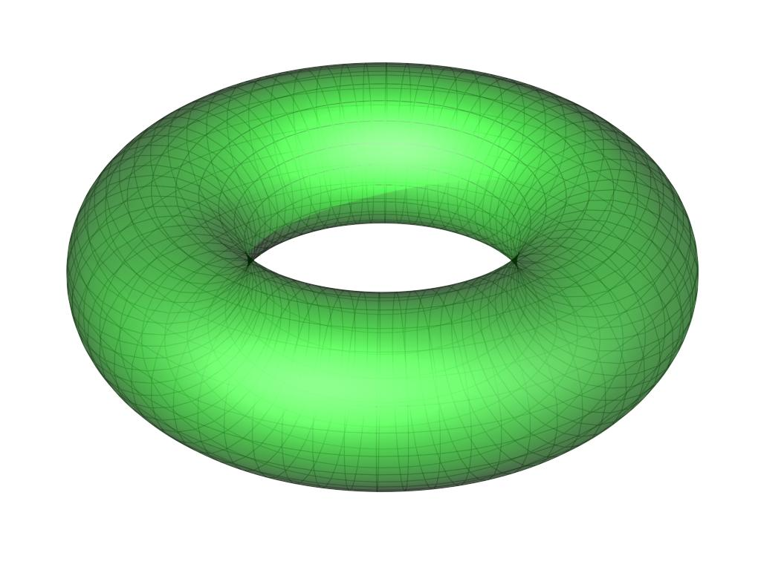
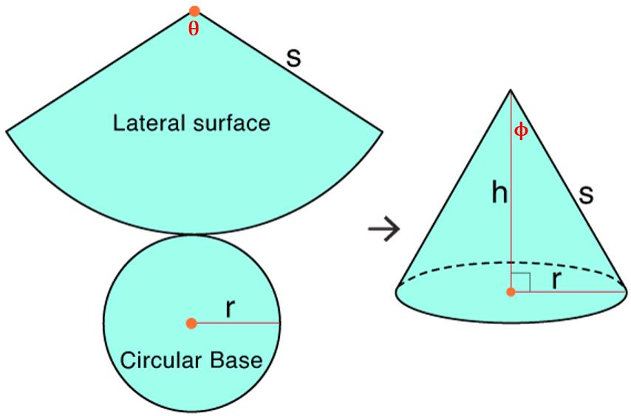

3. Closed Surface
# Source: AI Source: Provided by: [Data Path: Persons Table -> ID Column: 1, Name_En Column: Motasem Essam] -> From: [ChatGPT] on [7/20/2026]
A closed surface completely encloses a three-dimensional region.
Examples:
- Sphere
- Surface of a cube
- Surface of a cylinder including its two circular bases
A closed surface separates an interior region from an exterior region.

4. Open Surface
# Source: AI Source: Provided by: [Data Path: Persons Table -> ID Column: 1, Name_En Column: Motasem Essam] -> From: [ChatGPT] on [7/20/2026]
An open surface does not completely enclose a three-dimensional region.
For example, the curved lateral surface of a cylinder without its circular bases is an open surface.

Surface and Solid
# Source: AI Source: Provided by: [Data Path: Persons Table -> ID Column: 1, Name_En Column: Motasem Essam] -> From: [ChatGPT] on [7/20/2026]
A surface should not be confused with a solid.
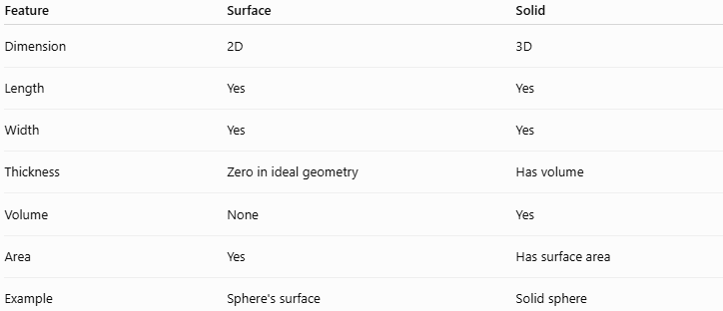
Feature | Surface | Solid
Dimension | 2D | 3D
Length | Yes | Yes
Width | Yes | Yes
Thickness | Zero in ideal geometry | Has volume
Volume | None | Yes
Area | Yes | Has surface area
Example | Sphere's surface | Solid sphere
For example, a sphere can be considered in two different ways:
$$\text{Sphere as a solid}→\text{has volume} \\ \text{Spherical surface}→\text{has surface area}$$

Surface Area
# Source: AI Source: Provided by: [Data Path: Persons Table -> ID Column: 1, Name_En Column: Motasem Essam] -> From: [ChatGPT] on [7/20/2026]
The surface area is the total area of the surfaces forming the boundary of a three-dimensional object.
Cube
For a cube with side length $s$:
$$SA=6s^{2}$$
Rectangular Prism
For length $l$, width $w$, and height $h$:
$$SA=2\left(lw+lh+wh\right)$$
Sphere
For a sphere of radius $r$:
$$SA=4πr^{2}$$
Cylinder
For a cylinder of radius $r$and height $h$:
$$SA=2πr^{2}+2πrh$$
where:
$$2πr^{2}$$
represents the two circular bases, and
$$2πrh$$
represents the curved lateral surface.

Surface as a Geometric Term
# Source: AI Source: Provided by: [Data Path: Persons Table -> ID Column: 1, Name_En Column: Motasem Essam] -> From: [ChatGPT] on [7/20/2026]
There is an important distinction between surface and plane.
Plane
A plane is a particular fundamental geometric object: a flat, infinite, two-dimensional geometric set.
Surface
A surface is a broader concept that can be flat or curved.
Therefore:
$$\boxed{\text{Every plane is a flat surface, but not every surface is a plane.}}$$
For example:
- A tabletop can be modeled as part of a plane.
- The surface of a sphere is curved and therefore is not a plane.

Is Surface an Undefined or Defined Term?
# Source: AI Source: Provided by: [Data Path: Persons Table -> ID Column: 1, Name_En Column: Motasem Essam] -> From: [ChatGPT] on [7/20/2026]
This is important in relation to your previous topic.
In classical Euclidean geometry, surface is one of Euclid's foundational concepts and appears among the traditional primitive notions. However, modern axiomatic geometry does not universally treat "surface" as one of the three standard undefined terms.
The traditional elementary list is usually:
$$\boxed{\text{Point, Line, Plane}}$$
So for your knowledge base, I recommend treating:
Surface → Fundamental Geometric Concept
rather than placing it alongside Point, Line, and Plane as one of the standard three undefined terms.

Examples

Example 1 — Tabletop
# Source: AI Source: Provided by: [Data Path: Persons Table -> ID Column: 1, Name_En Column: Motasem Essam] -> From: [ChatGPT] on [7/20/2026]
A tabletop can be modeled geometrically as a portion of a:
$$\boxed{\text{Plane Surface}}$$

Example 2 — Sphere
# Source: AI Source: Provided by: [Data Path: Persons Table -> ID Column: 1, Name_En Column: Motasem Essam] -> From: [ChatGPT] on [7/20/2026]
The outer boundary of a ball is a:
$$\boxed{\text{Curved Surface}}$$
Its interior is not part of the surface.

Example 3 — Cube
# Source: AI Source: Provided by: [Data Path: Persons Table -> ID Column: 1, Name_En Column: Motasem Essam] -> From: [ChatGPT] on [7/20/2026]
A cube has six square faces.
Therefore, its boundary consists of six flat surfaces:
$$6×s^{2}$$
and its total surface area is:
$$SA=6s^{2}$$

Real-World Applications
# Source: AI Source: Provided by: [Data Path: Persons Table -> ID Column: 1, Name_En Column: Motasem Essam] -> From: [ChatGPT] on [7/20/2026]
Surfaces are important in:
- Architecture and construction
- Mechanical engineering
- Manufacturing
- Painting and coating
- Packaging
- Computer graphics and 3D modeling
- CAD
- Astronomy
- Physics
- Surface measurement
- Material science
For example, determining how much paint is required for an object requires calculating the relevant surface area.

Key Points
# Source: AI Source: Provided by: [Data Path: Persons Table -> ID Column: 1, Name_En Column: Motasem Essam] -> From: [ChatGPT] on [7/20/2026]
- A surface is a two-dimensional geometric object or boundary in space.
- An ideal surface has no thickness.
- Surfaces may be flat or curved.
- A plane is a special type of flat surface.
- The boundary of a 3D object is its surface.
- Surface area measures the total area of a surface.
- Surface is especially important in Solid Geometry.
- In your taxonomy, Surface fits naturally under Euclidean Geometry → Solid Geometry → Fundamental Geometric Concepts.

Conclusion
# Source: AI Source: Provided by: [Data Path: Persons Table -> ID Column: 1, Name_En Column: Motasem Essam] -> From: [ChatGPT] on [7/20/2026]
A surface is a fundamental geometric concept used to represent a two-dimensional extent or the boundary of a three-dimensional object. Surfaces may be flat, such as planes and the faces of polyhedra, or curved, such as the surface of a sphere, cylinder, or cone. The concept is fundamental to Solid Geometry and to the study of surface area.
Would you like a concise comparison of a plane, surface, and solid?

